Assignment
CO3 AT3 -Assignment 2
COURSE NAME: STATISTICS WITH R PROGRAMMING COURSE CODE: ITA04
Name : Sakthi Manoj R Reg No : 192324236

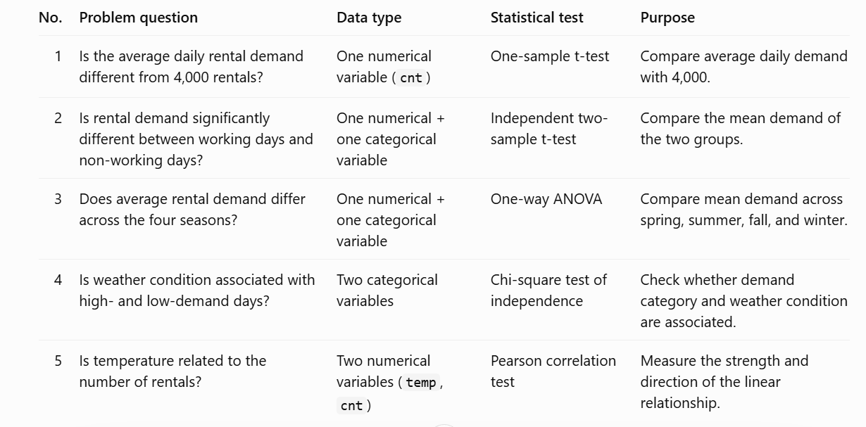

- Is the average daily rental demand different from 4,000 rentals?
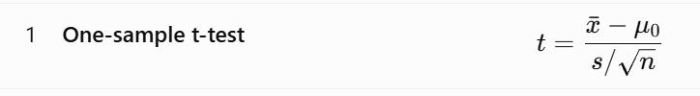
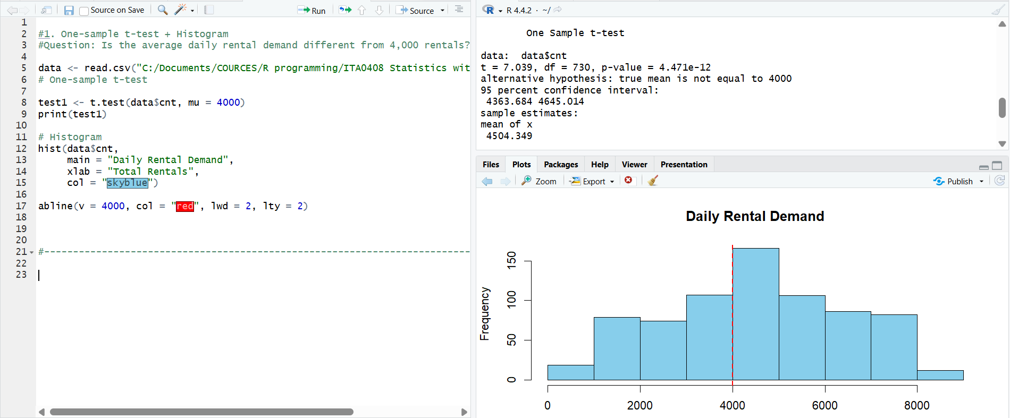
- Is rental demand significantly different between working and non-working days?
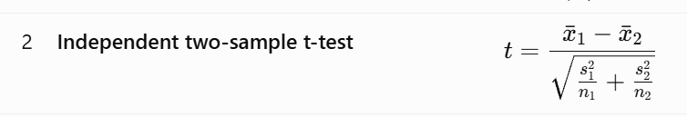
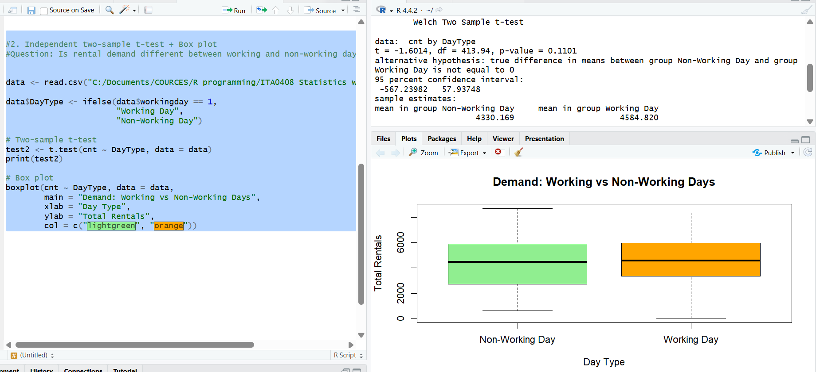
- Does average rental demand differ across the four seasons?
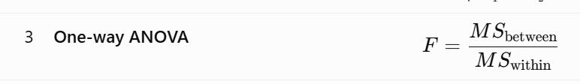

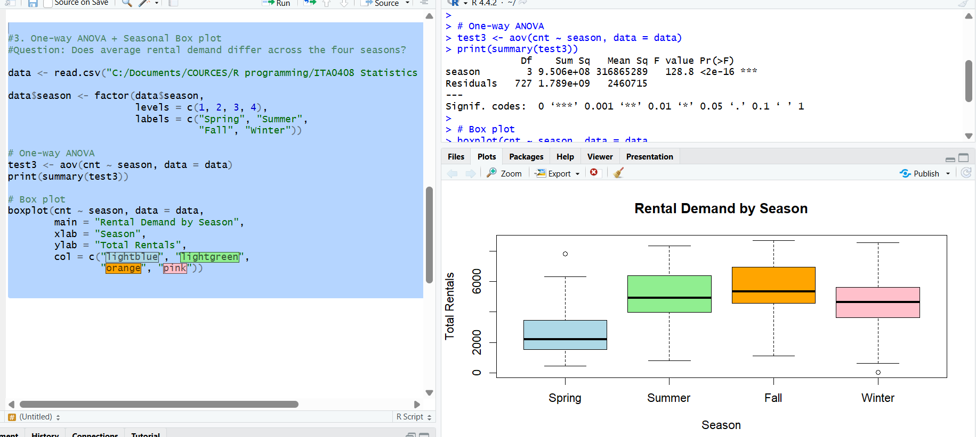
- Is weather condition associated with high- and low-demand days?

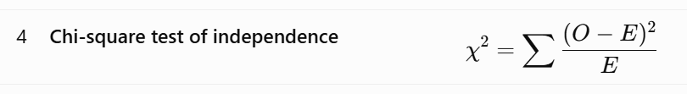
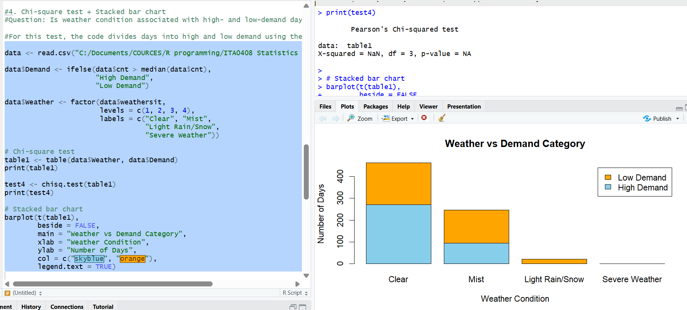

- Is temperature related to the number of rentals?

